• **Sign in to the AWS Management Console**

* Go to the [AWS Management Console](https://aws.amazon.com/console/).
* Sign in with your credentials.

• **Navigate to IAM (Identity and Access Management)**

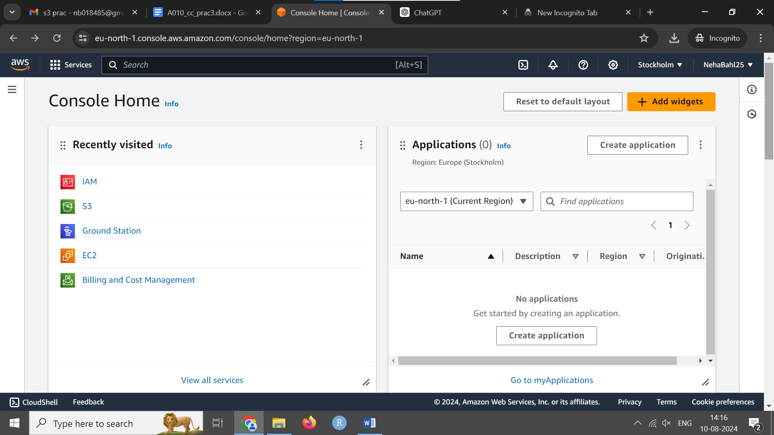

**Create a New User**

* In the IAM dashboard, click on "Users" in the sidebar.
* Click the “Add user” button.
* Enter the user name in the "User name" field.

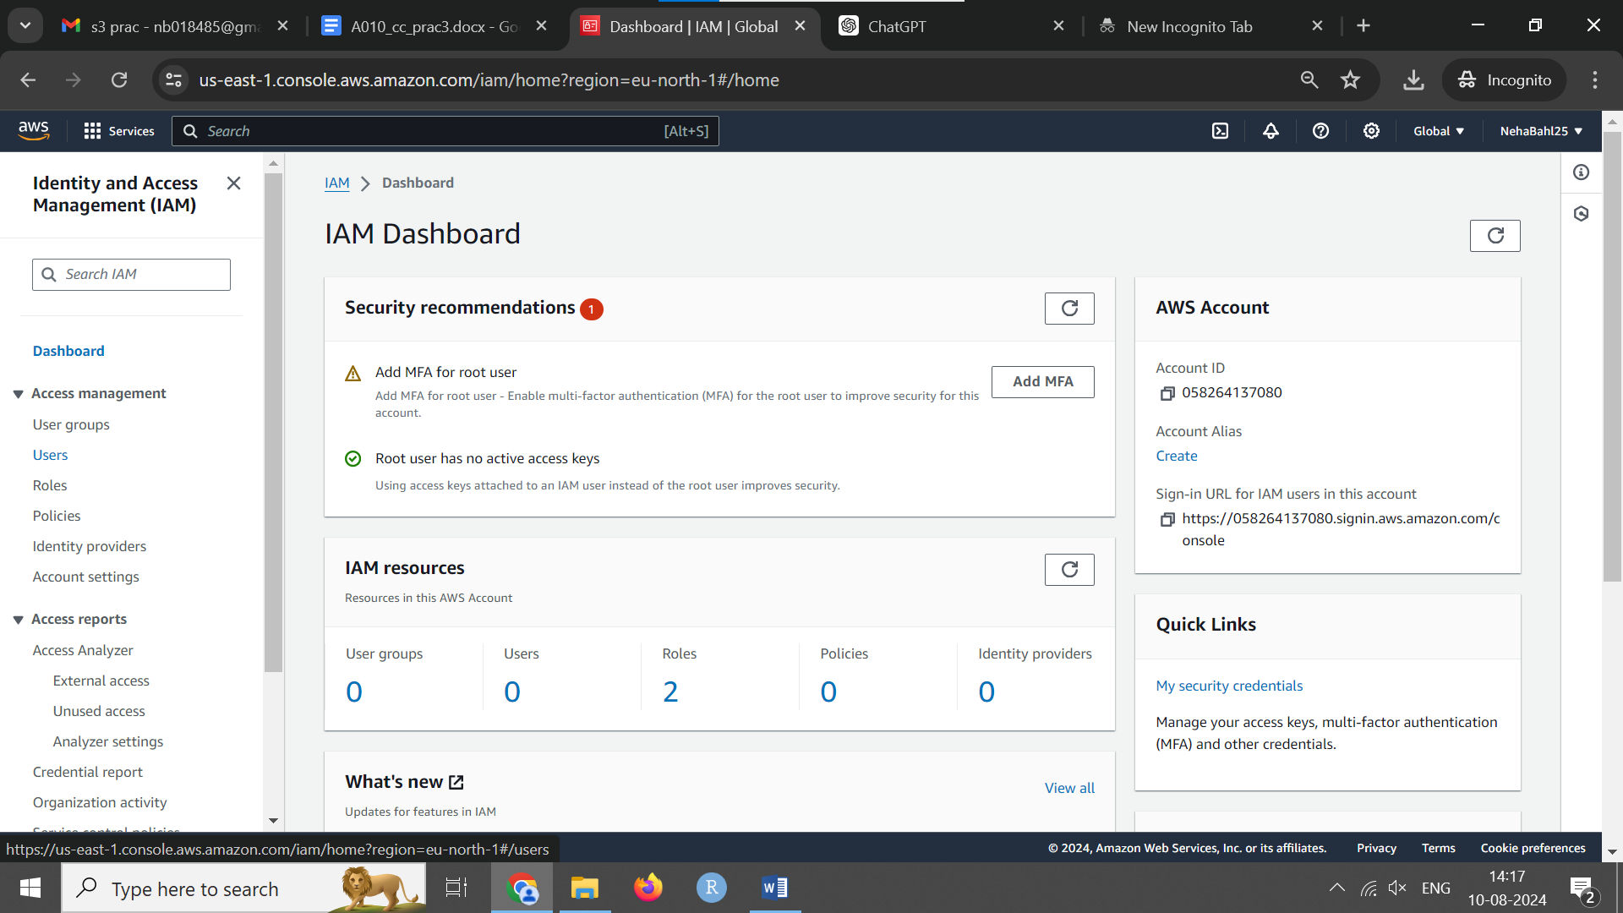

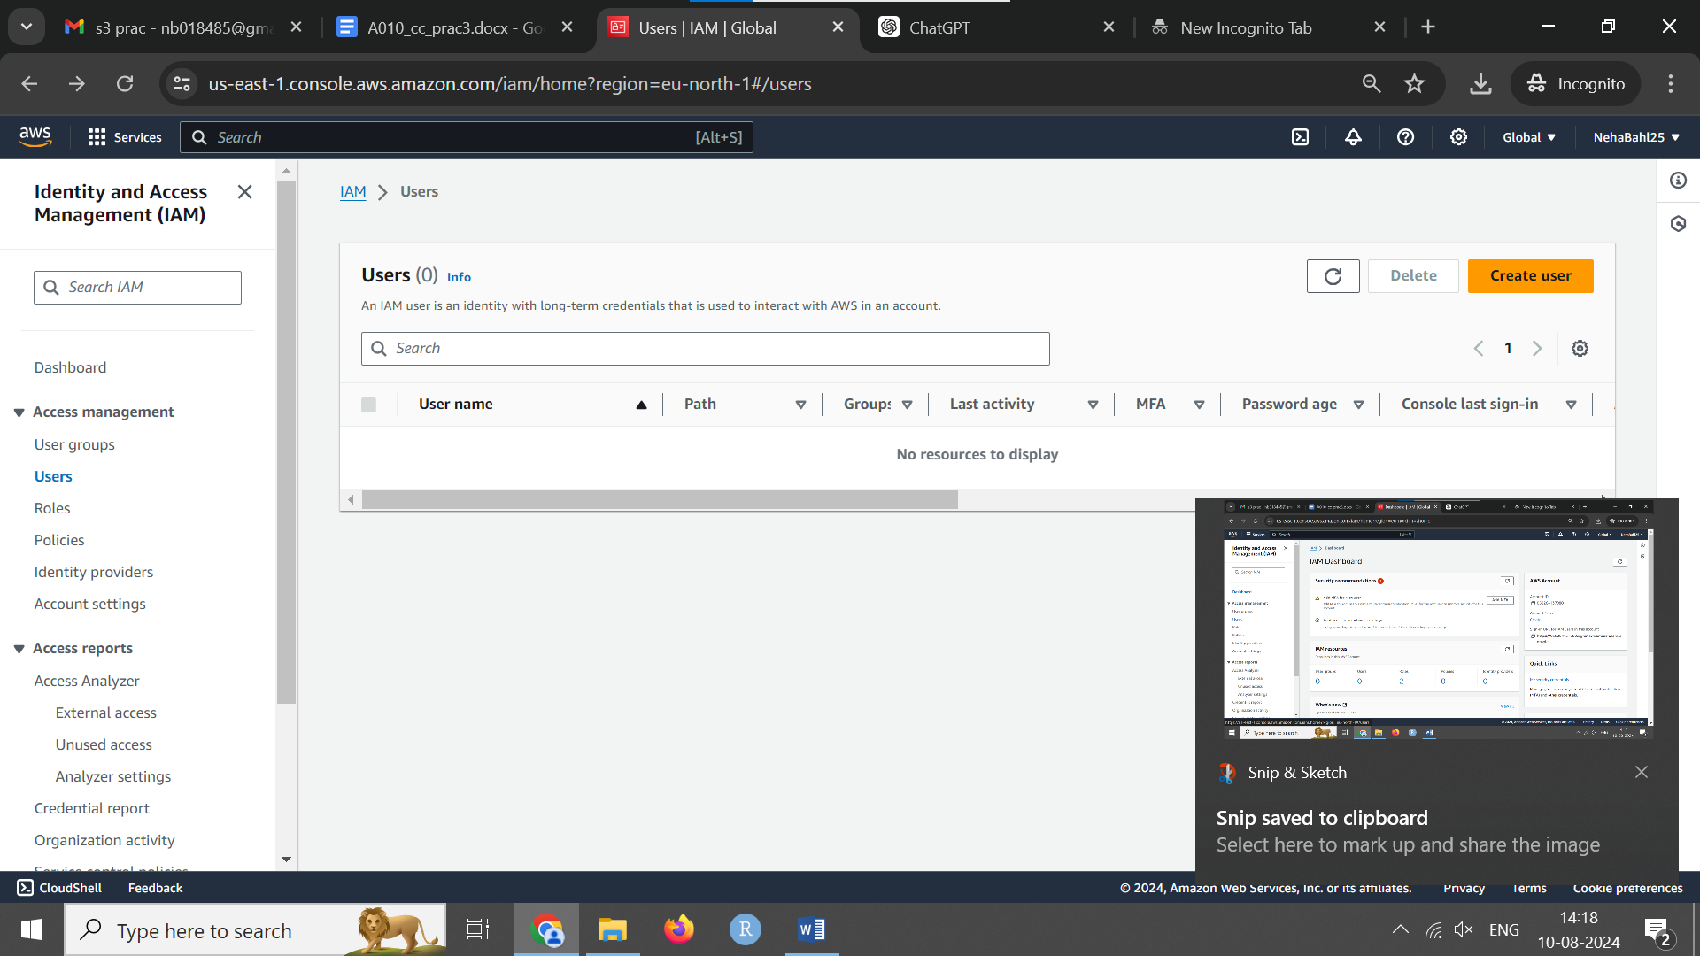

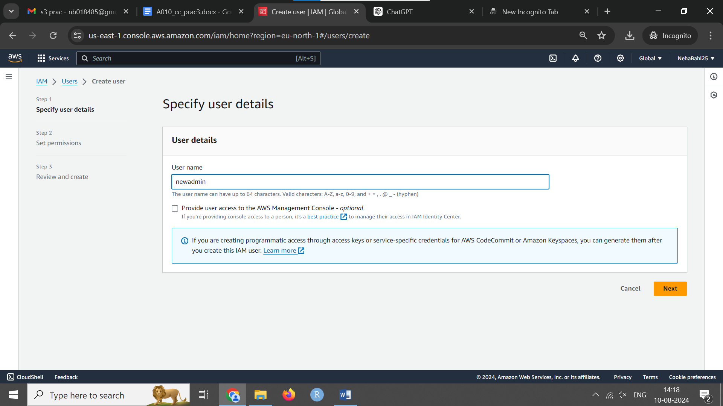

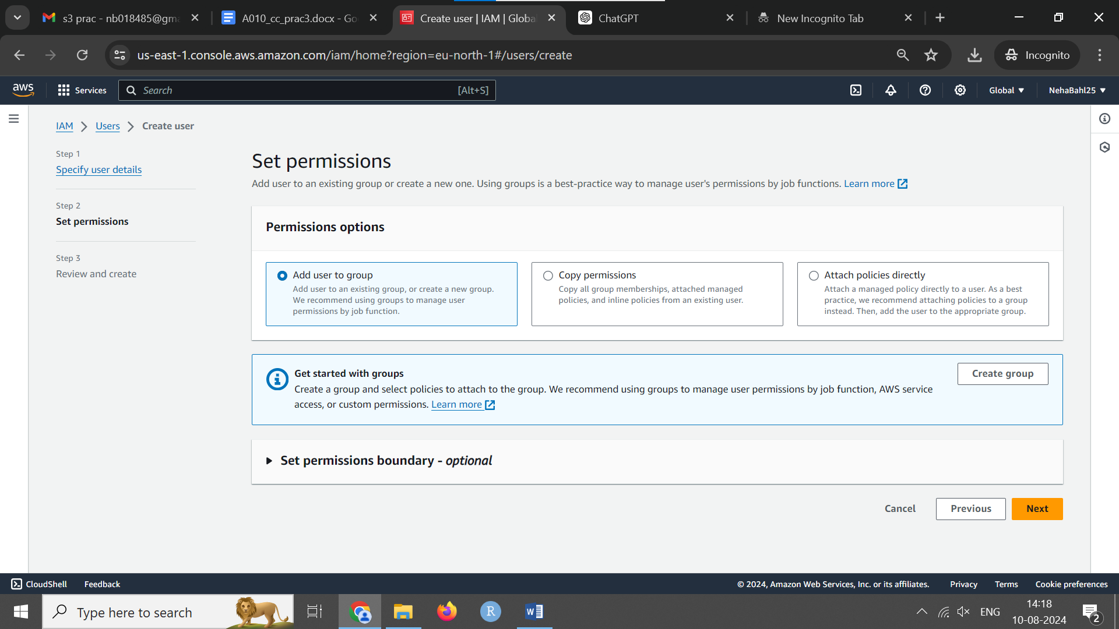

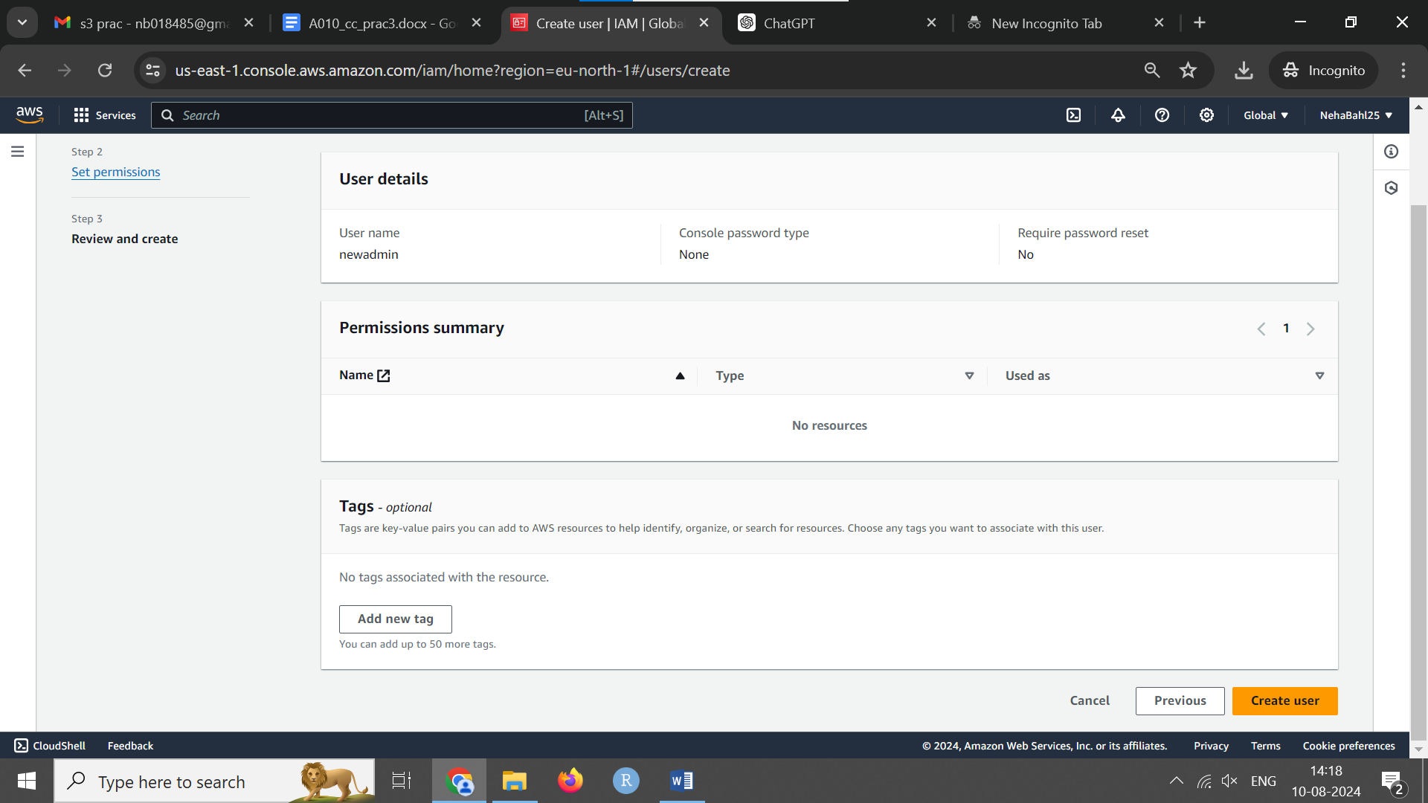

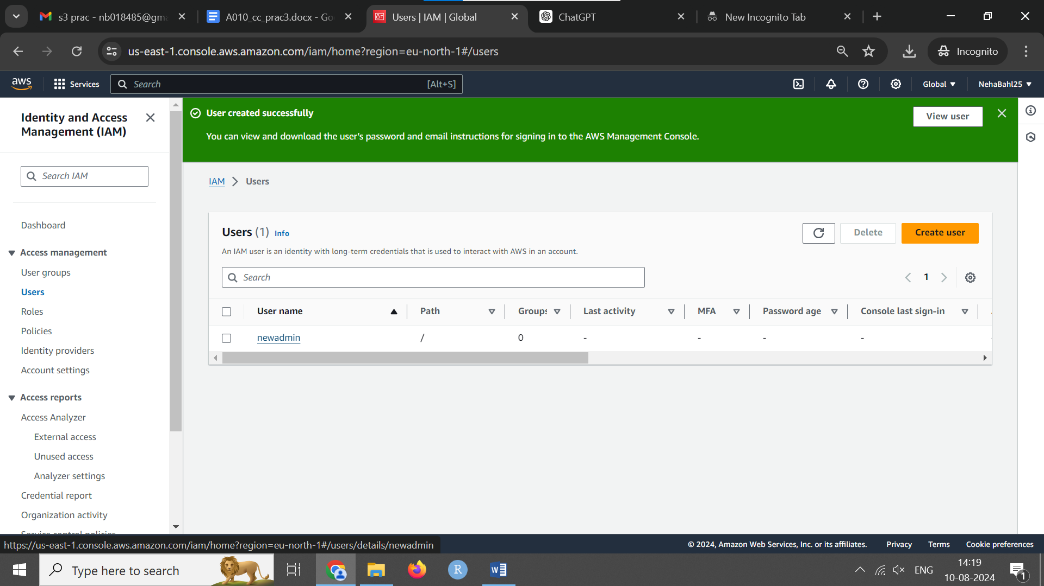

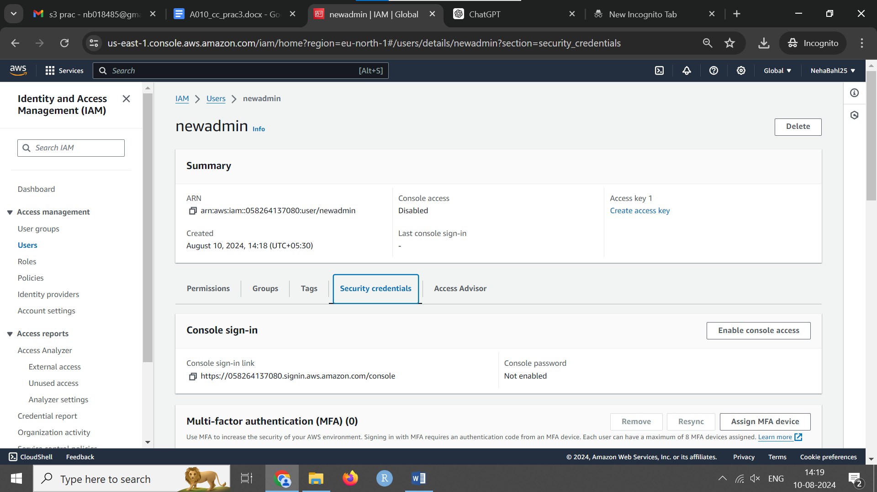

Revisit the user and go to security credentials. Download csv file with password and enable console access.

Copy link and sign in using aim to check that you don’t have permissions

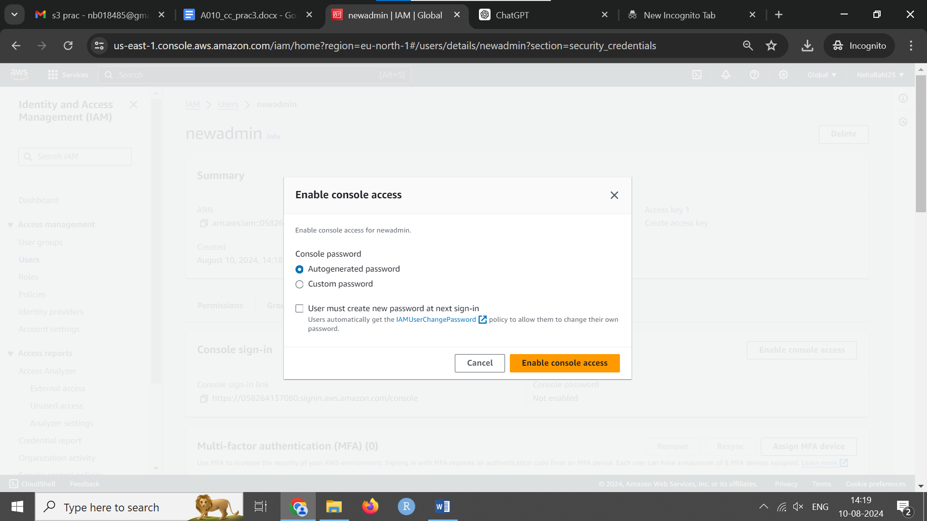

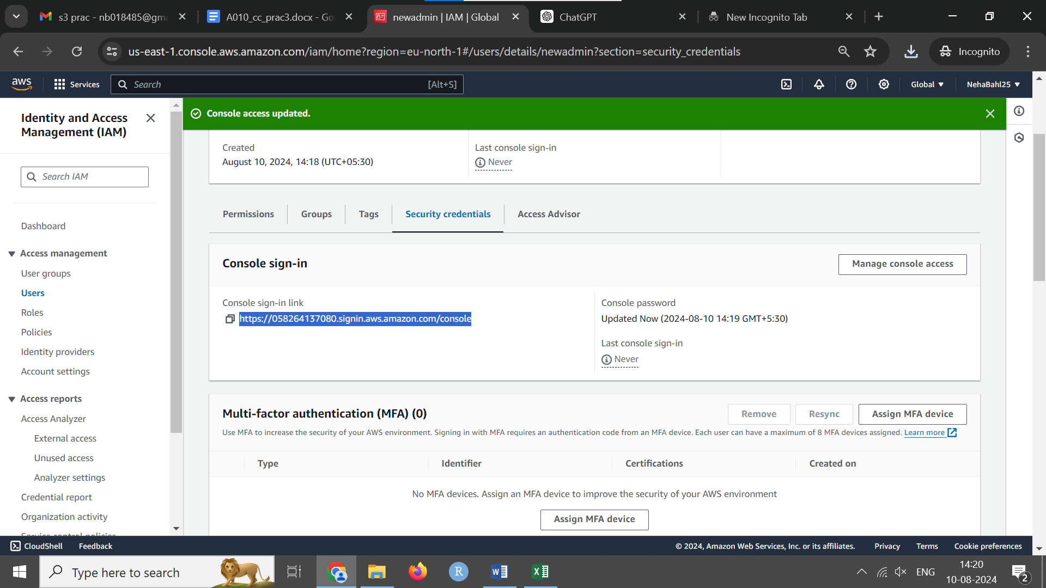

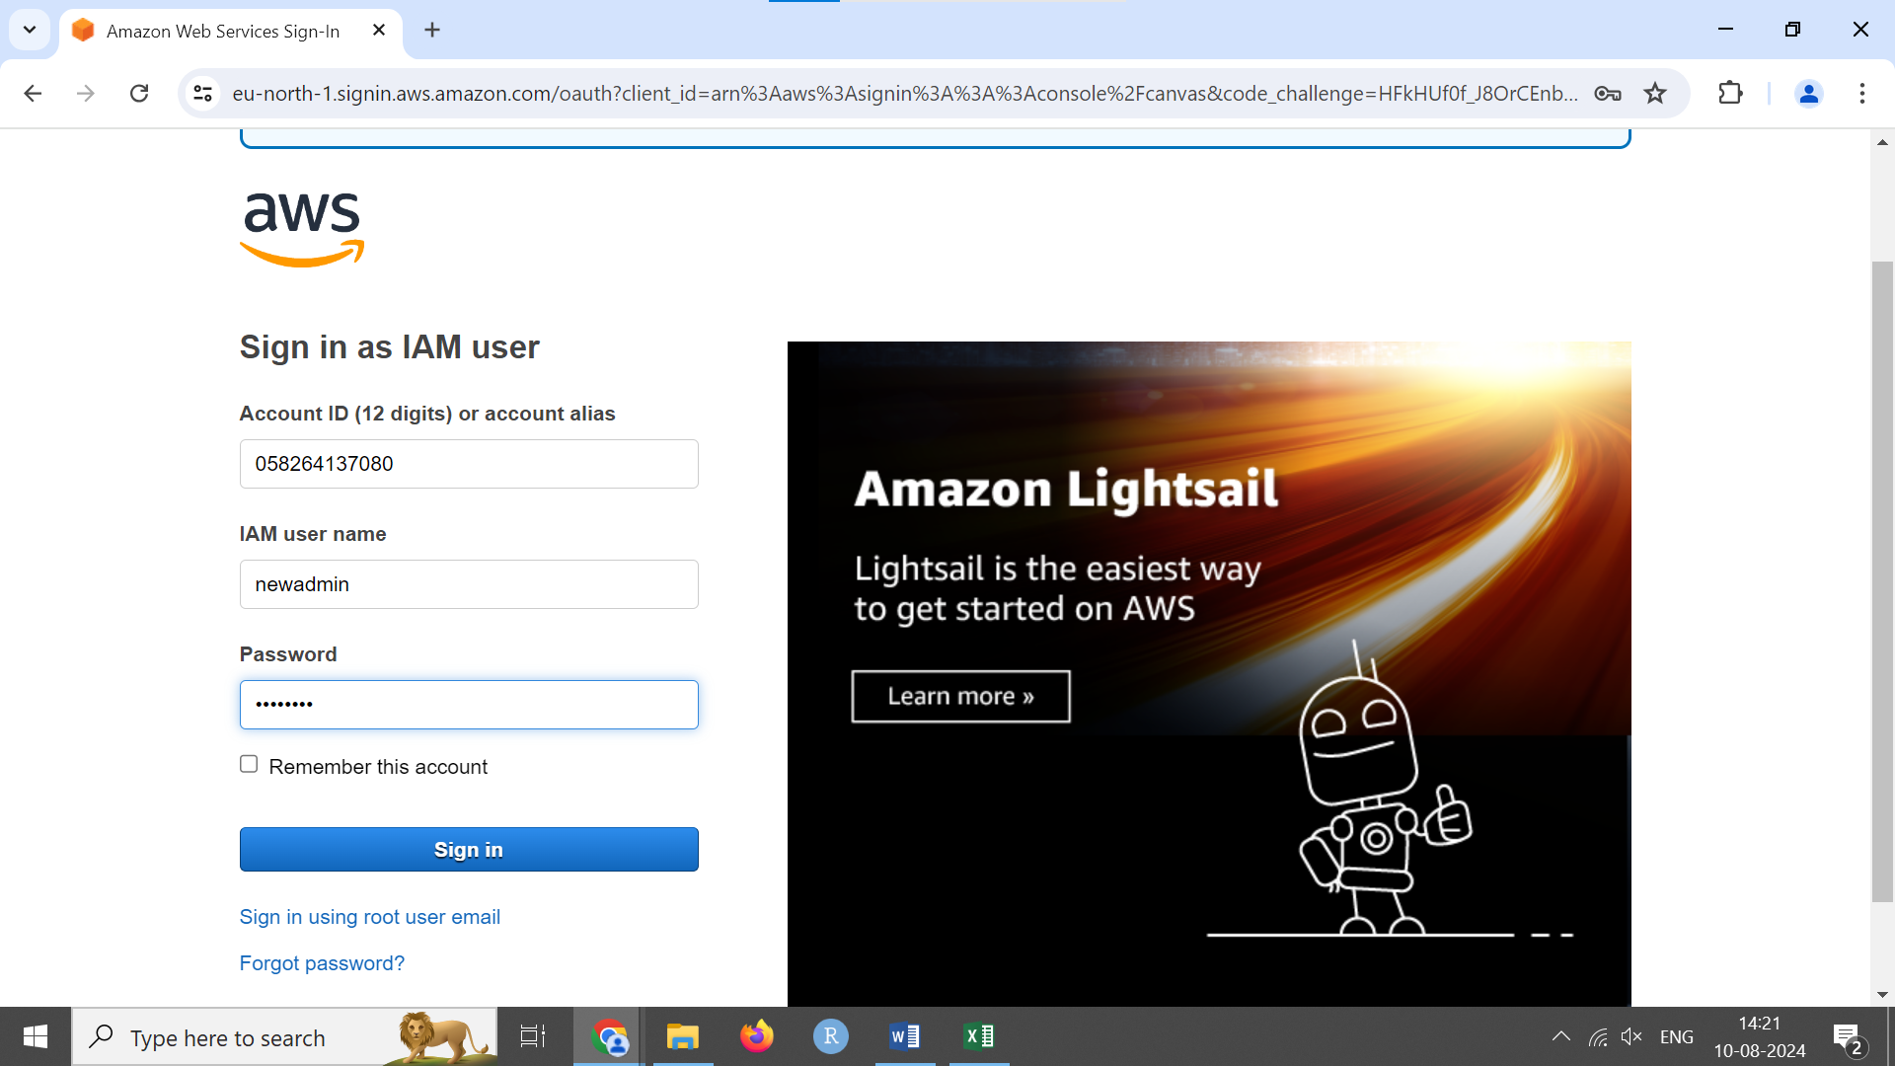

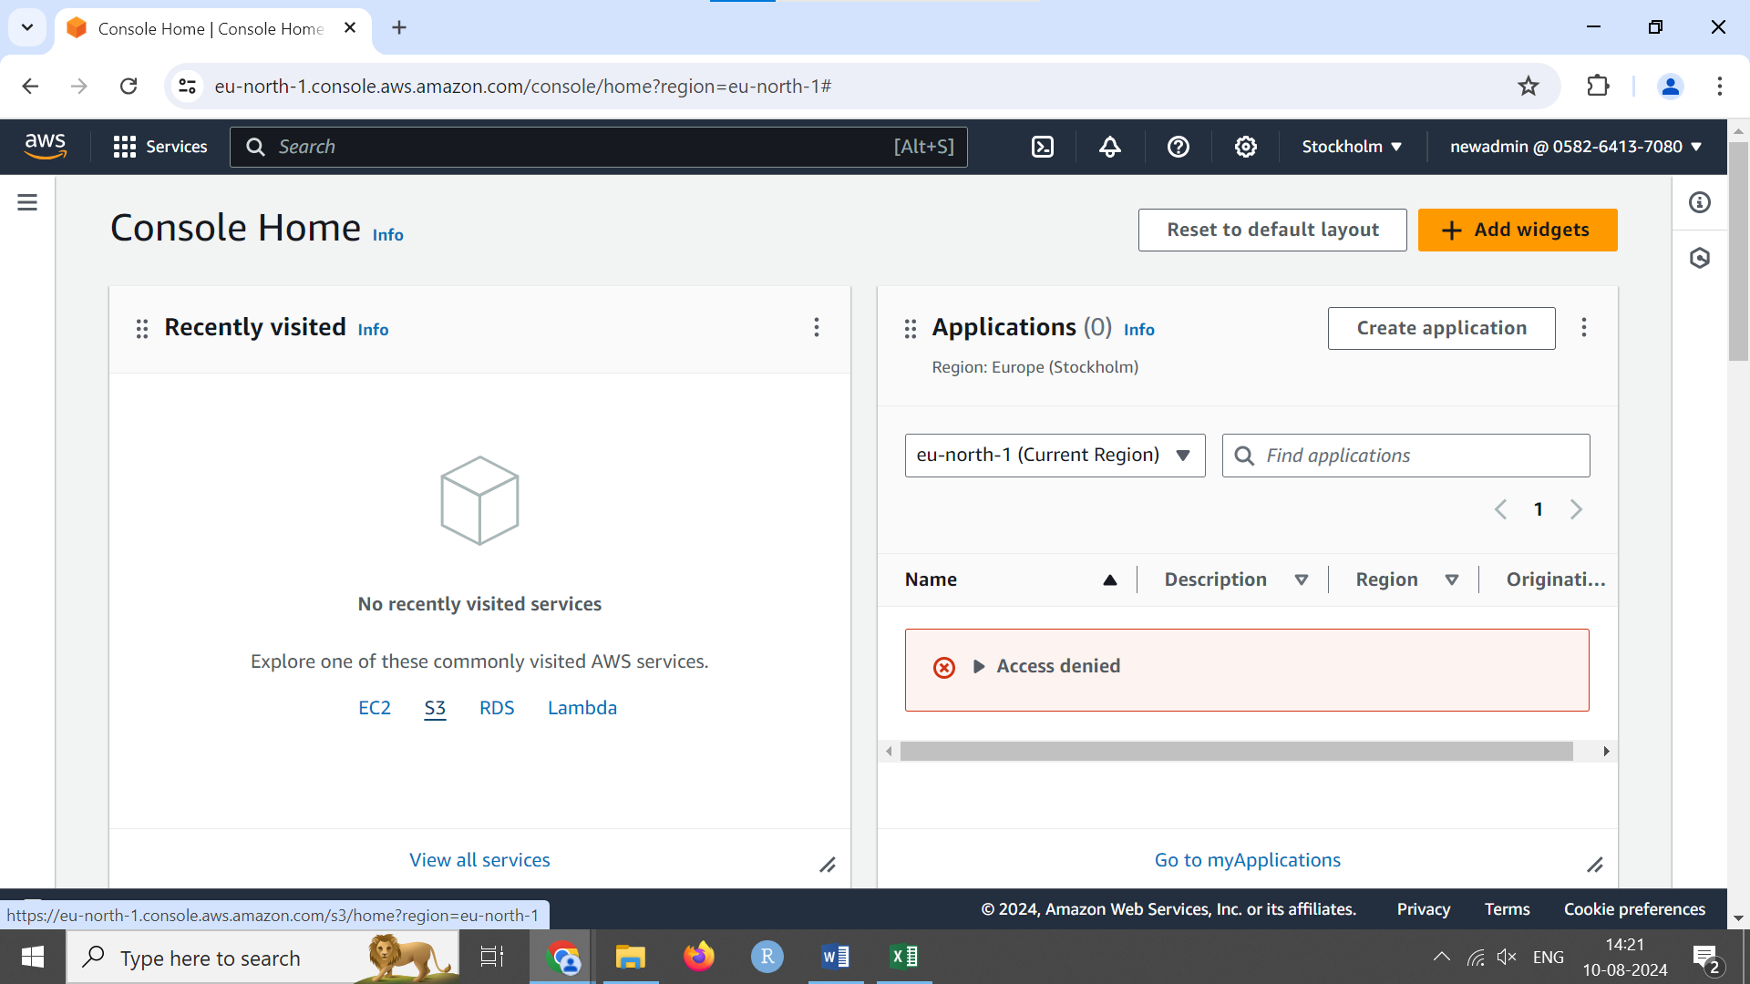

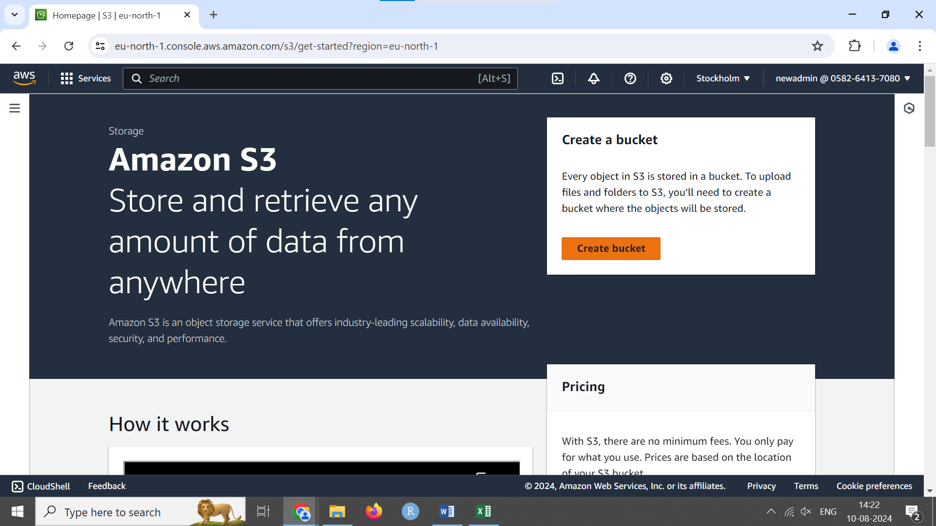

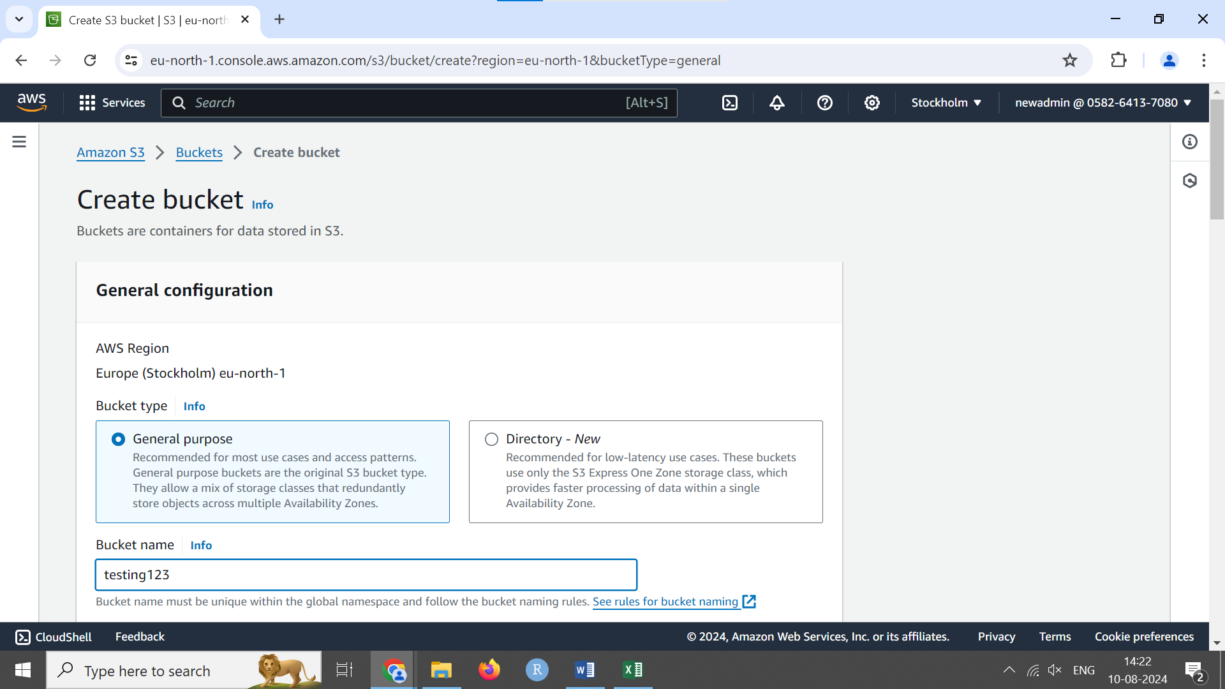

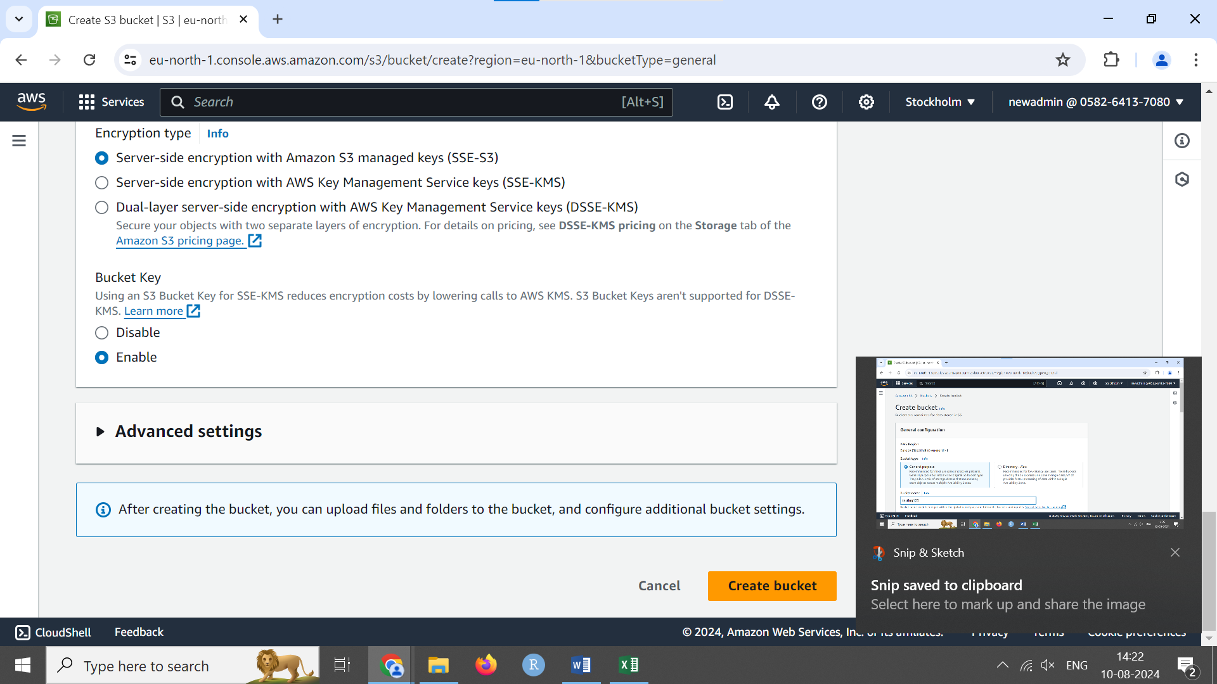

Cant create bucket. No permissions

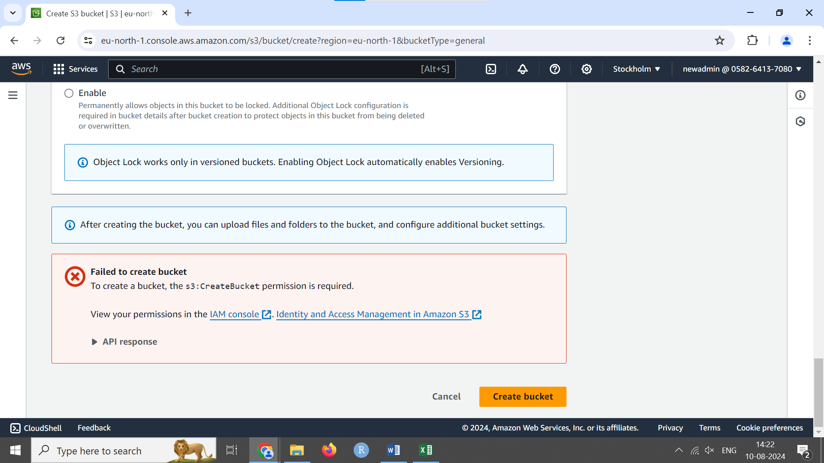

**Step 2: Create a New Policy**

1. **Navigate to Policies**
   * In the IAM dashboard, click on "Policies" in the sidebar.
   * Click the “Create policy” button.

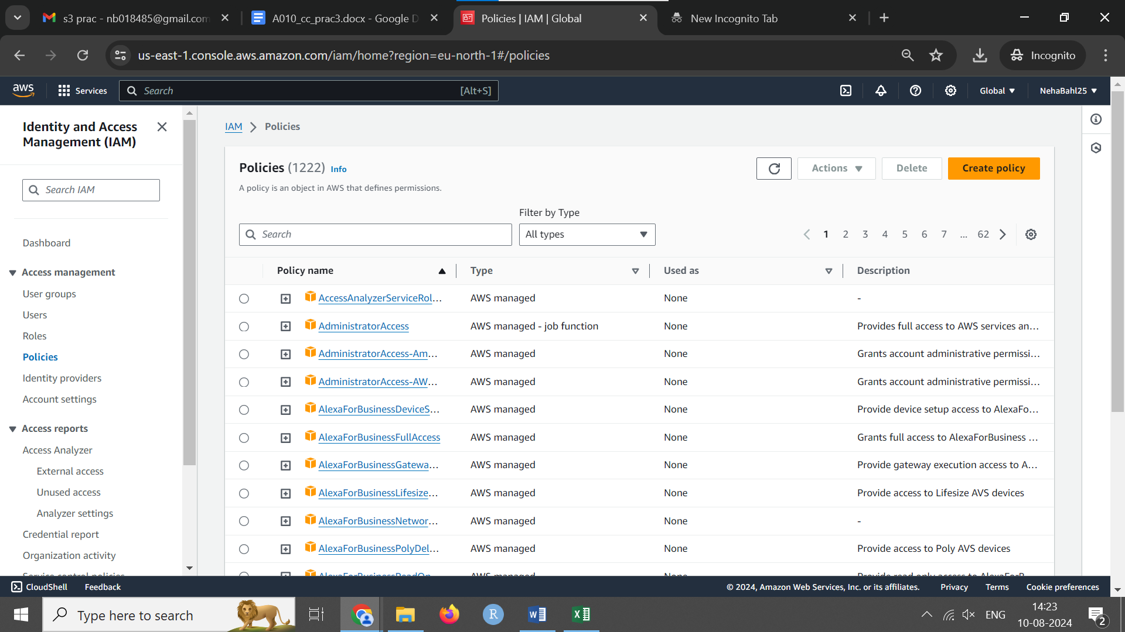

Select service like s3

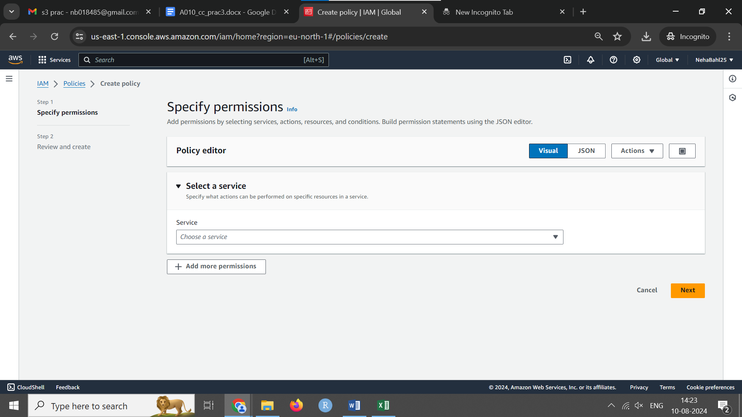

Allow all s3 actions and resources.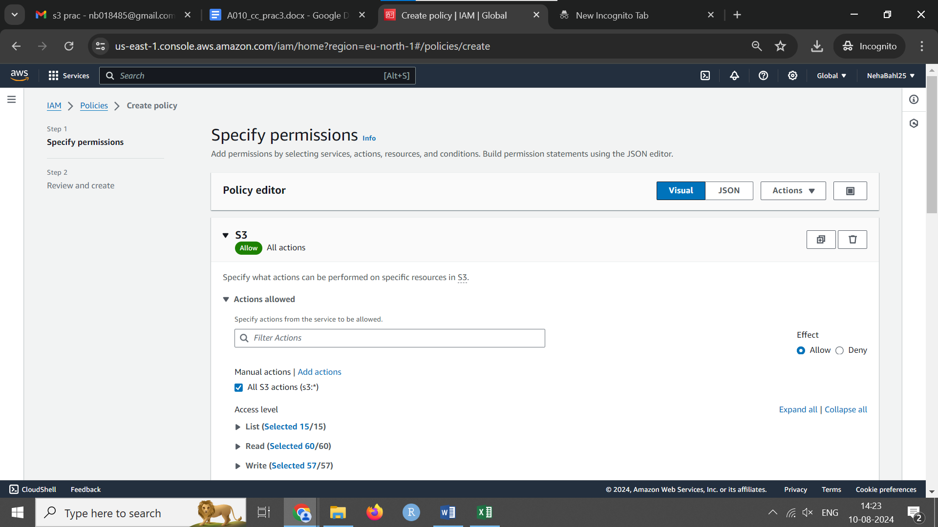

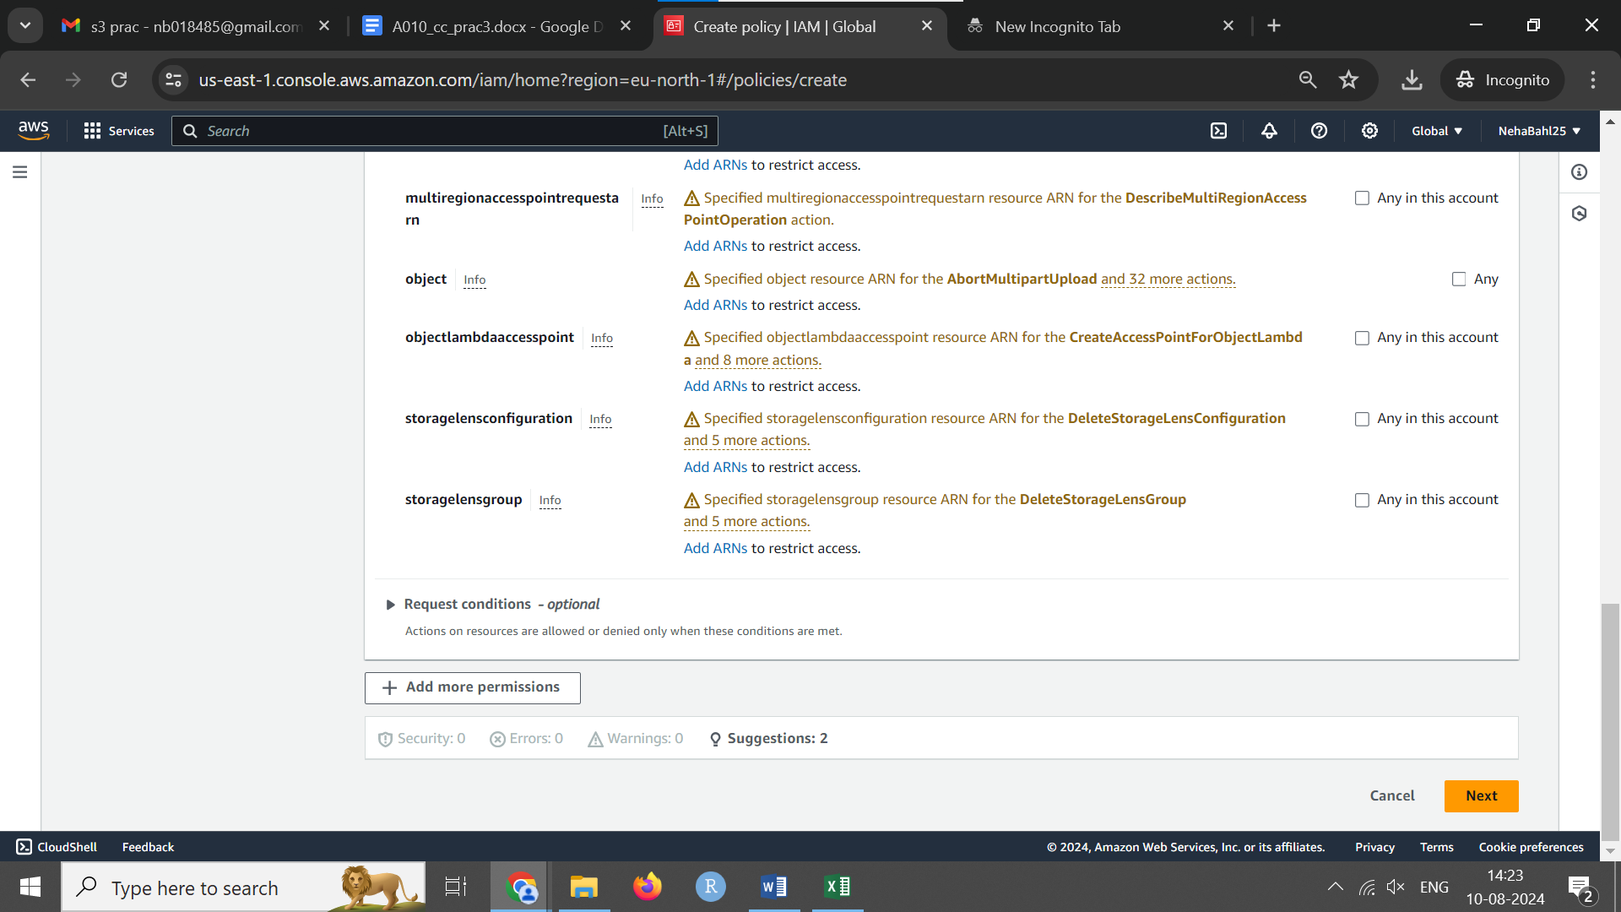

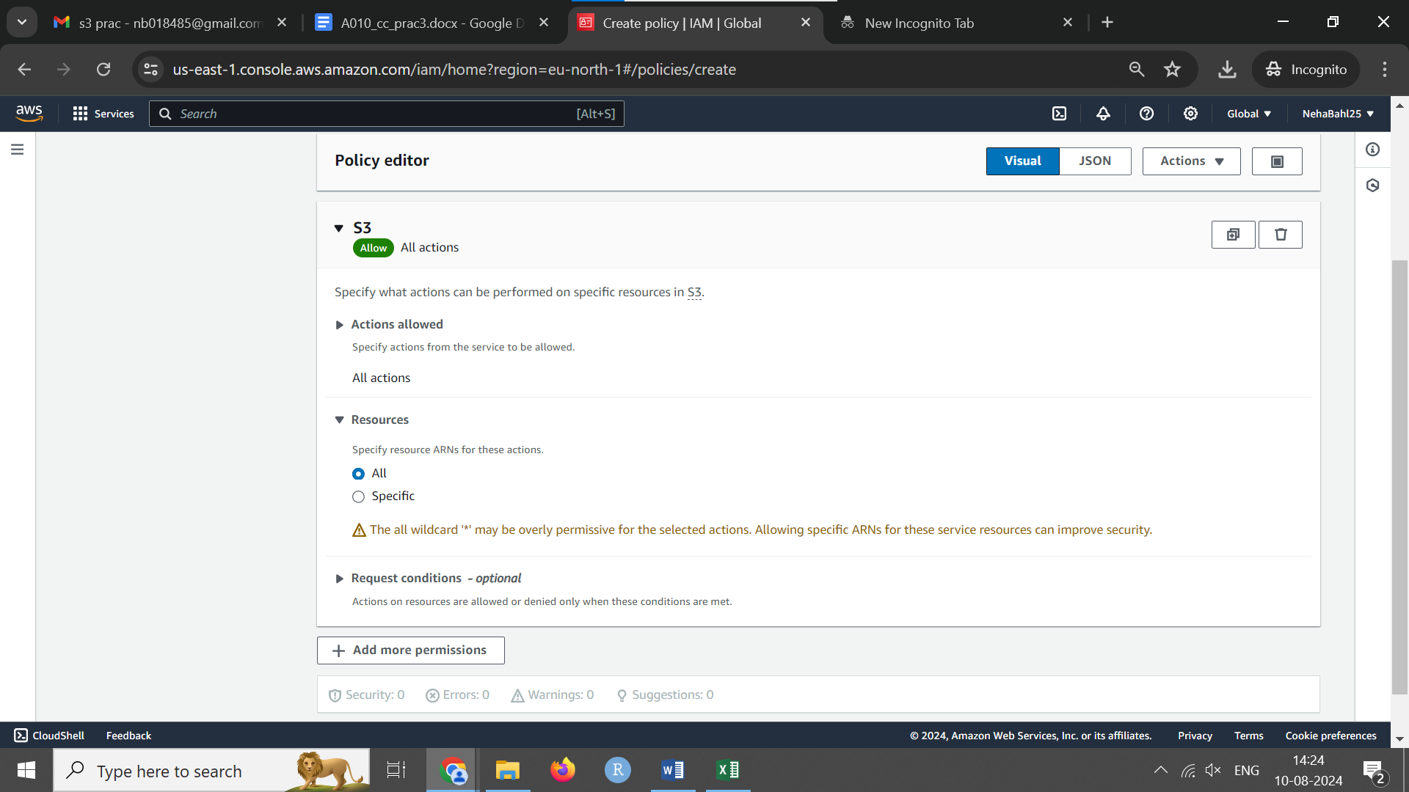

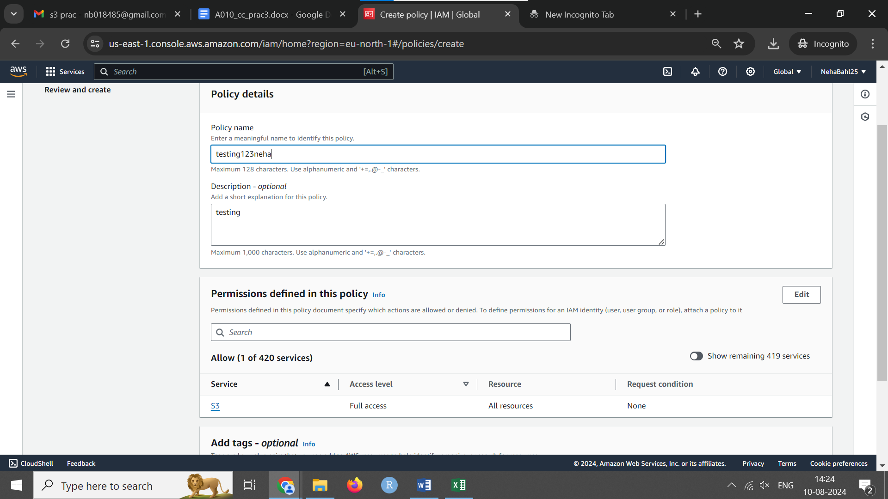

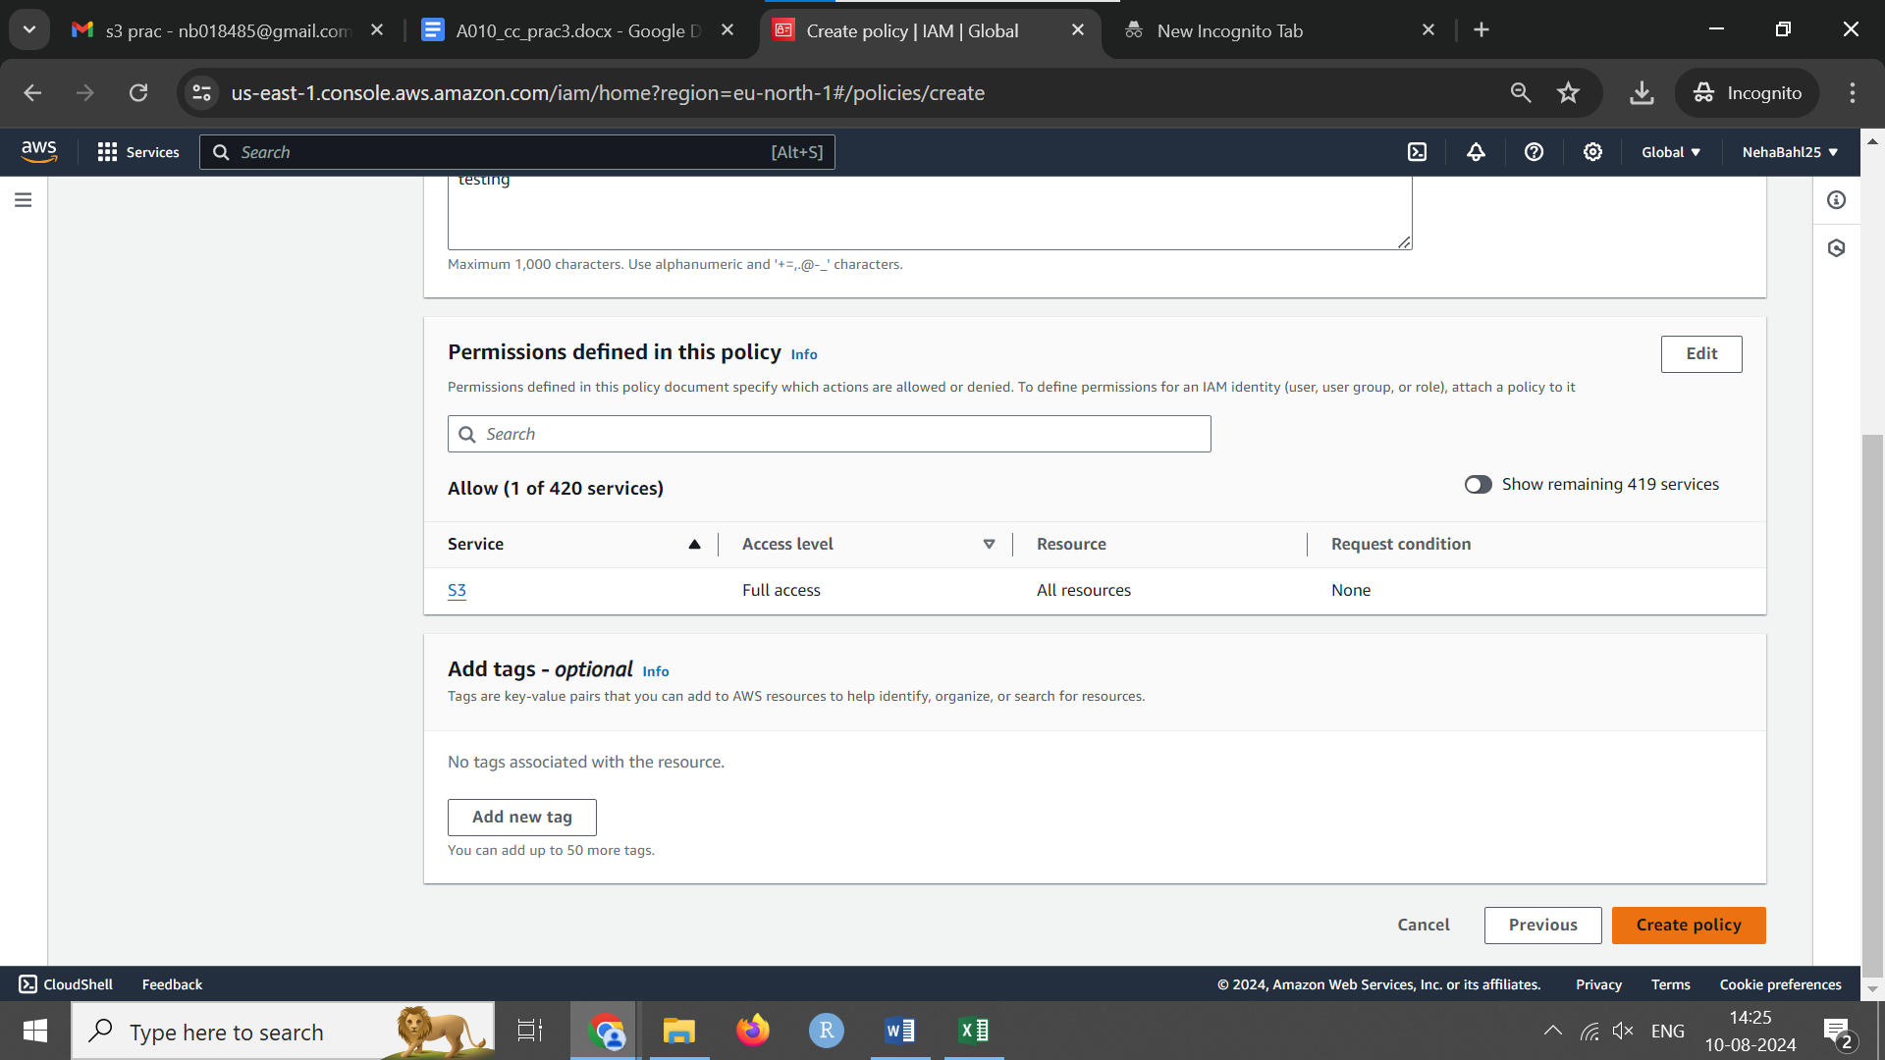

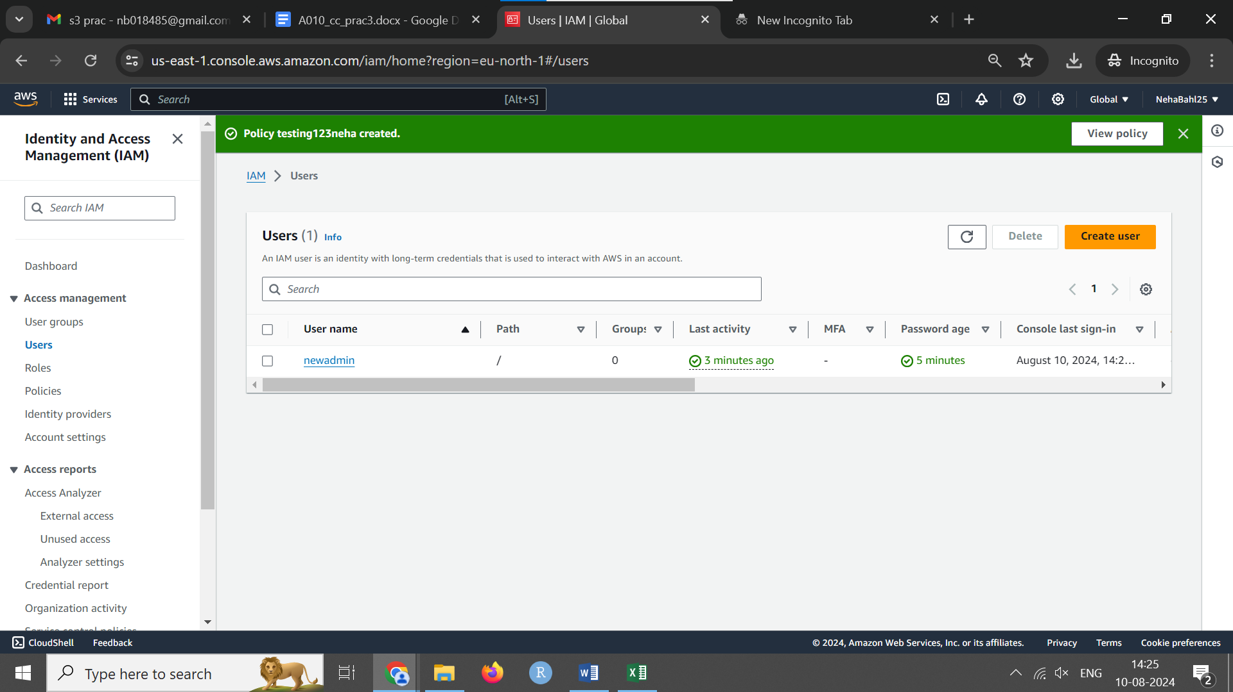

**Define Policy**

* **JSON**: Write your policy in JSON format directly. Change visualeditor to name of user for us-newadmin

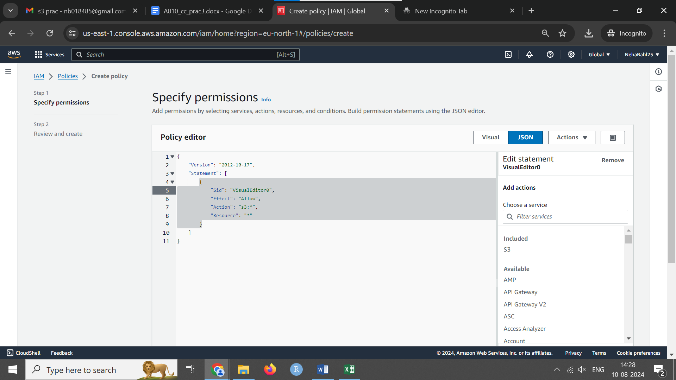

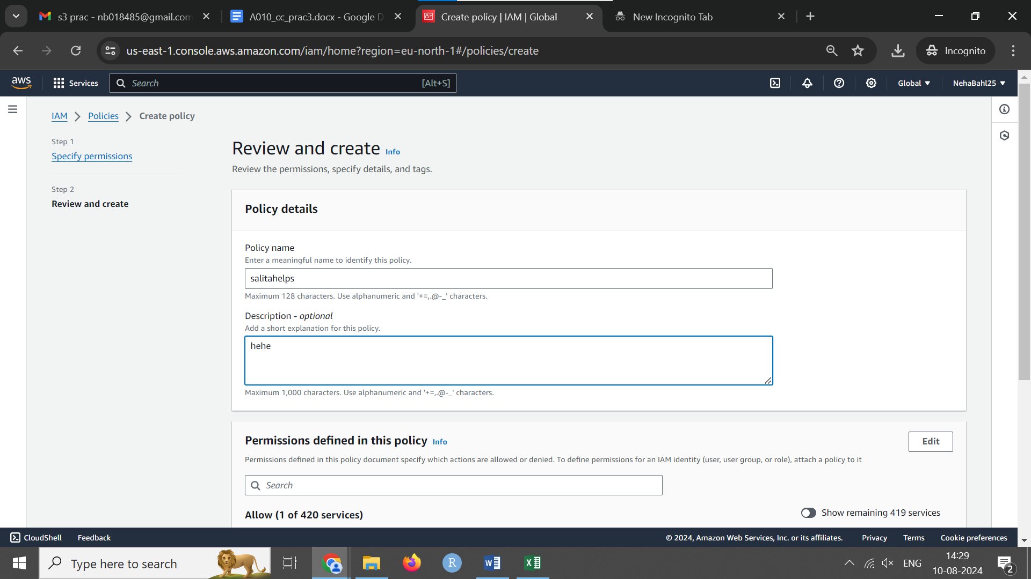

**Review and Create Policy**

* Click the “Review policy” button.
* Enter a name for the policy and an optional description.
* Click “Create policy”.

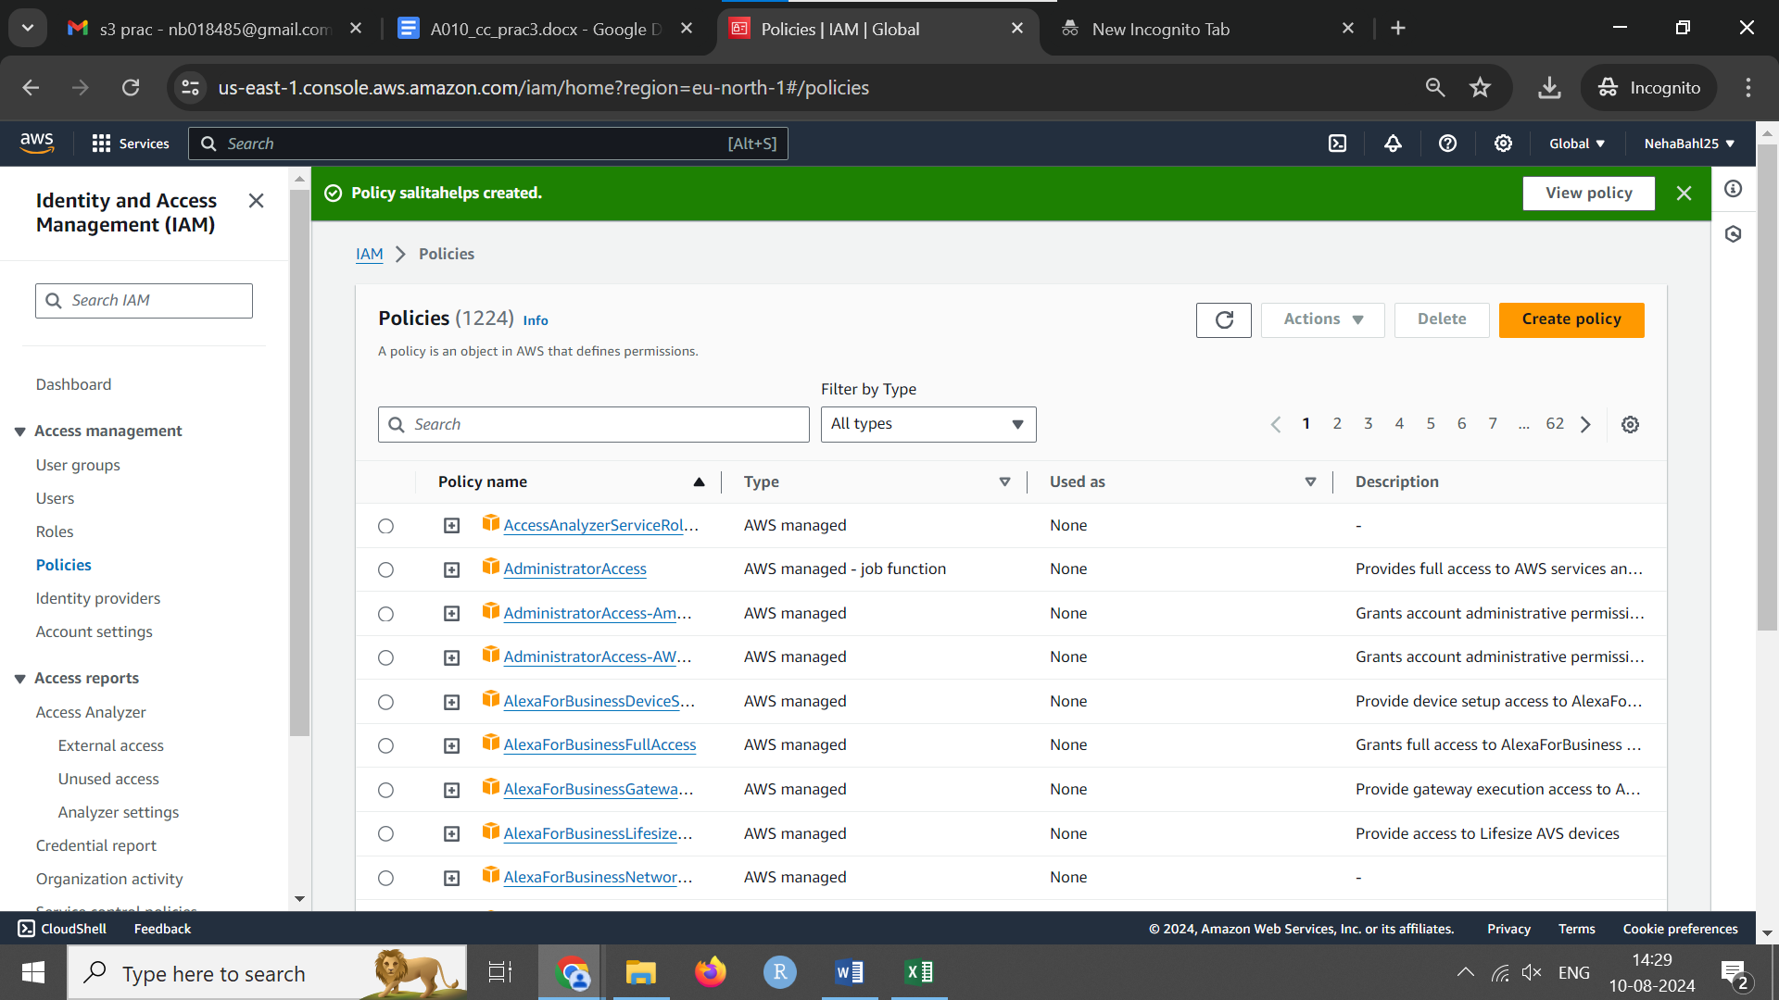

Go back to users and give them the policy.

### Step 3: Attach Policy to the New User

1. **Navigate to Users**
   * Go back to the “Users” section in the IAM dashboard.
   * Click on the user to whom you want to attach the policy.

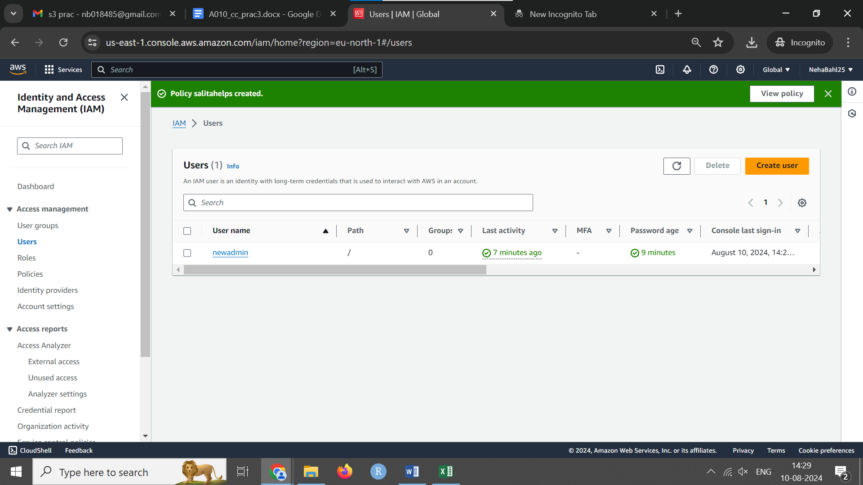

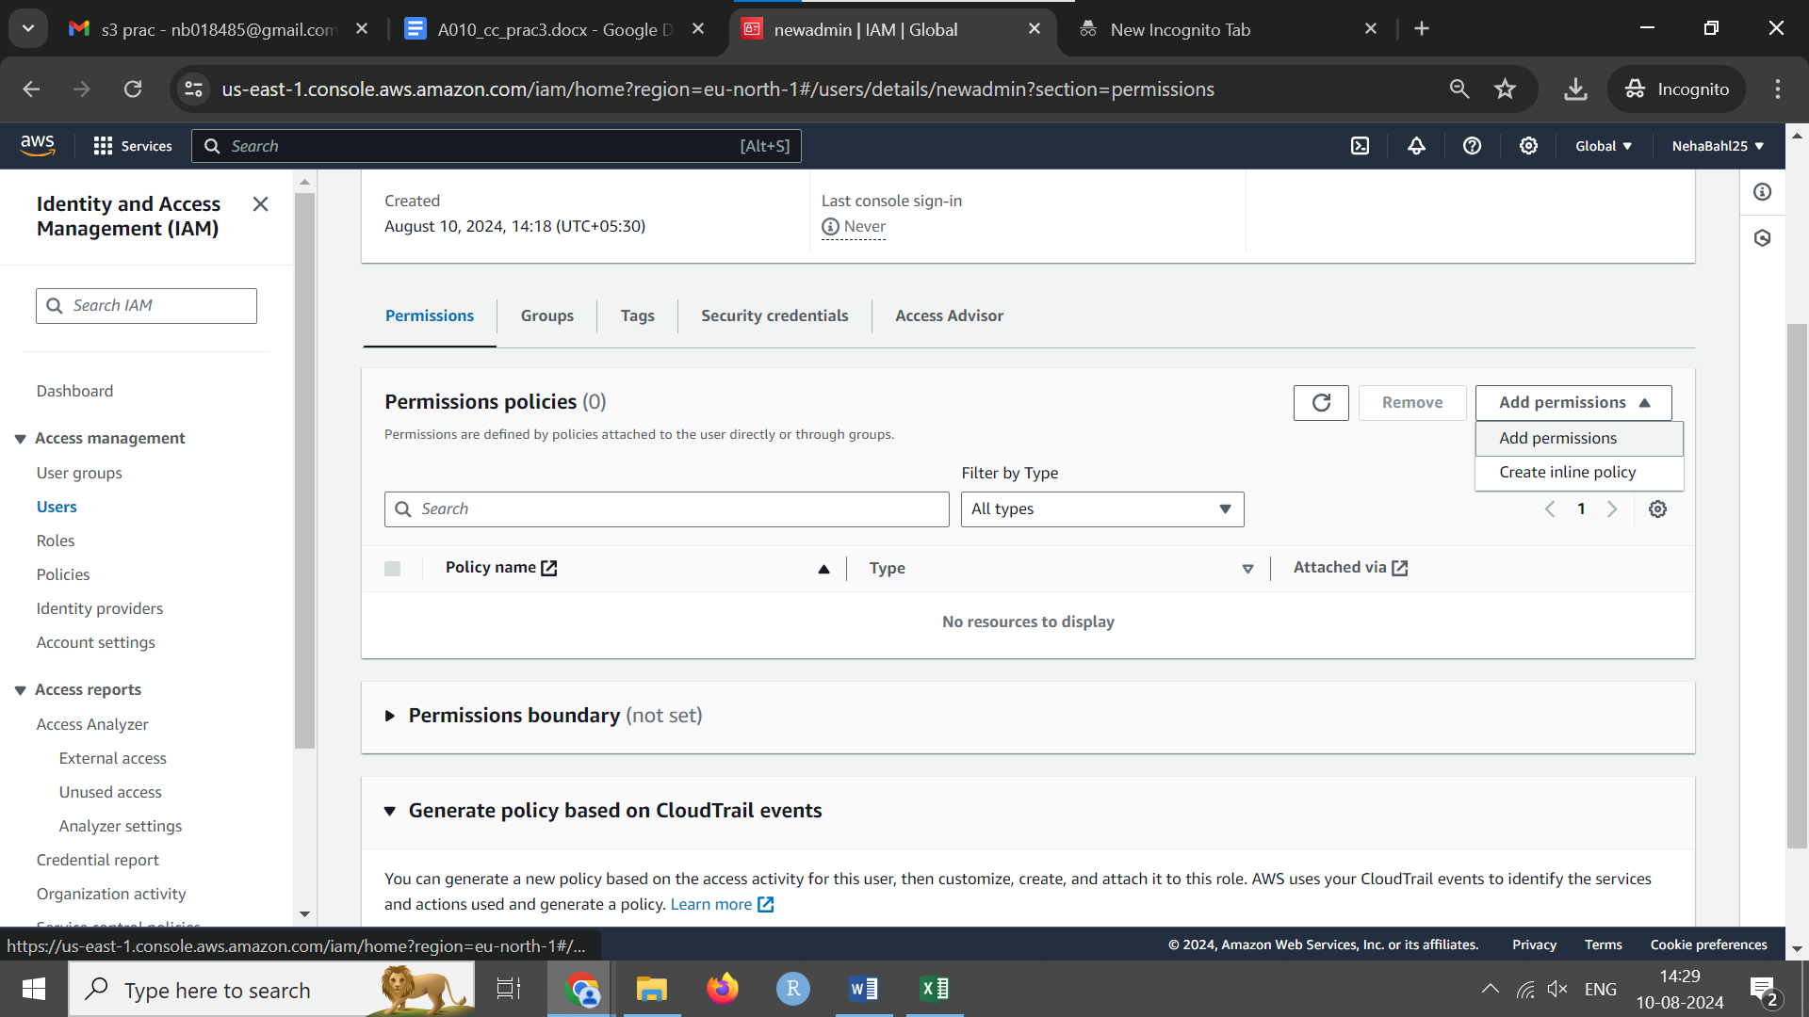

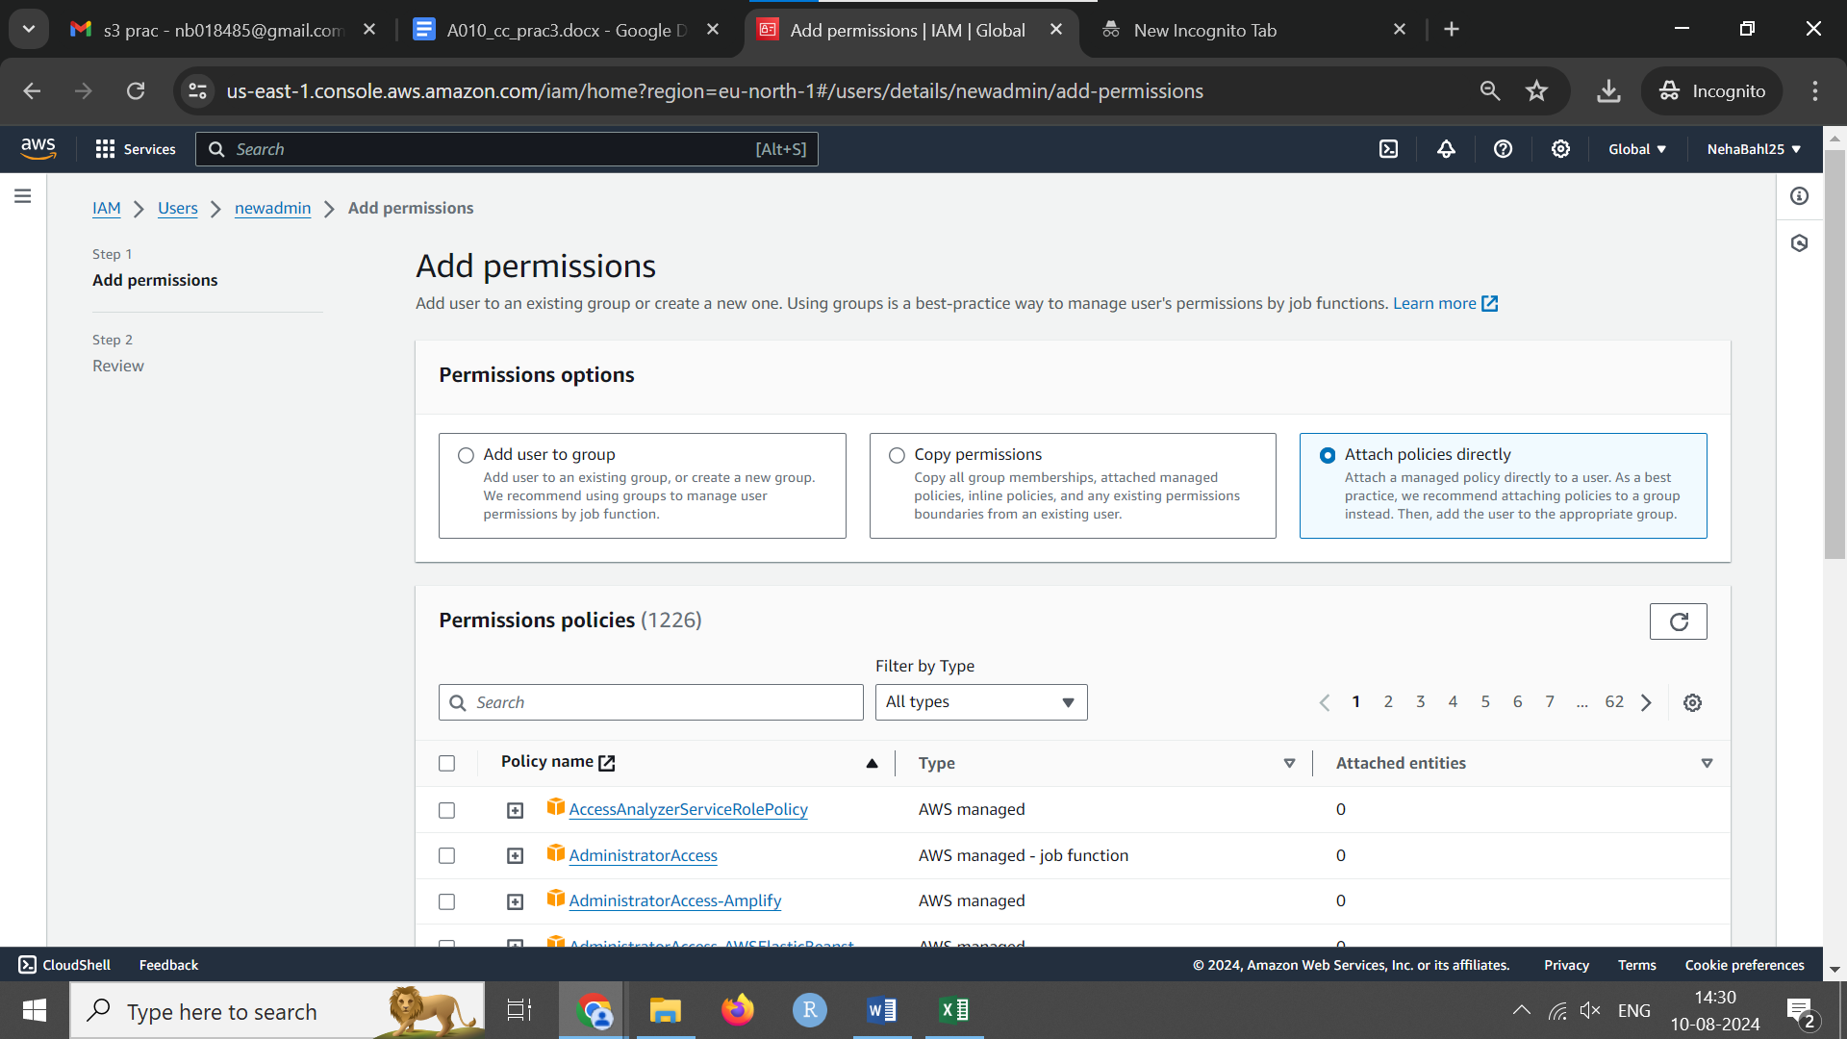

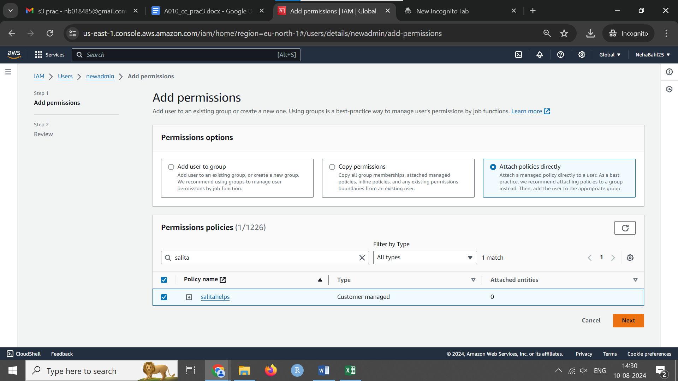

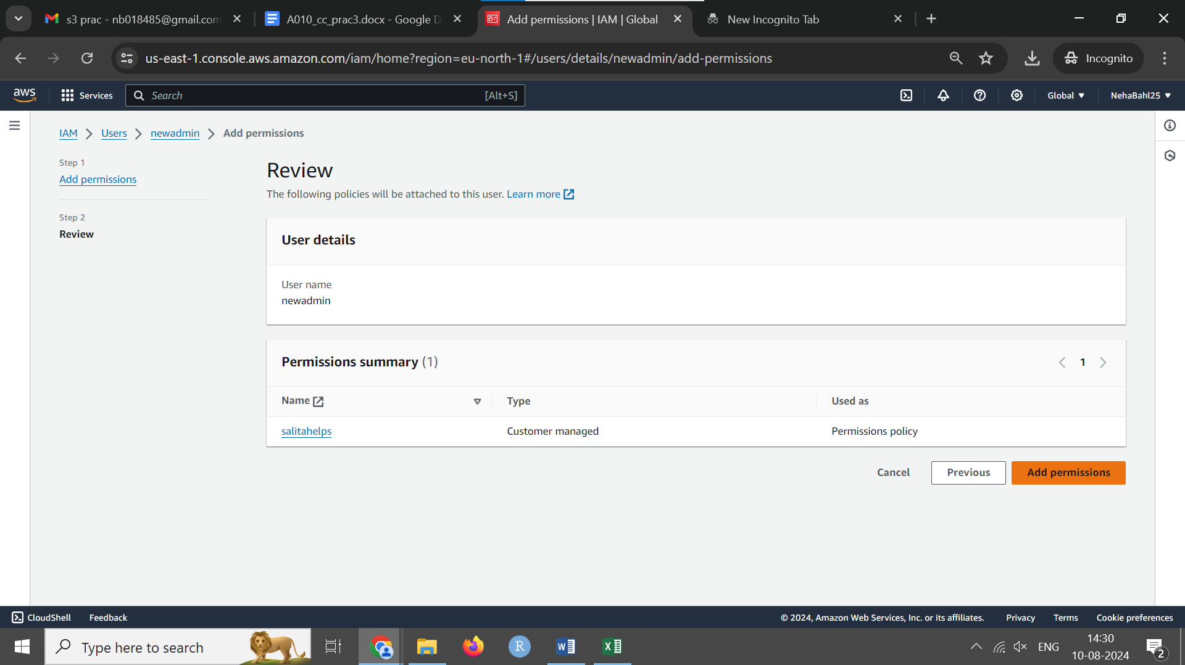

**Attach Policy**

* Click on the “Permissions” tab.
* Click the “Add permissions” button.
* Select “Attach policies directly”.
* Search for and select the newly created policy.
* Click “Next: Review”.
* Click “Add permissions” to attach the policy to the user.

Now you will be able to create bucket and so on. We can do this for ec2 as well.

